Intensive workshop
Turin, Campus Luigi Einaudi
3-6 June 2019

AFRICA ON THE MOVE
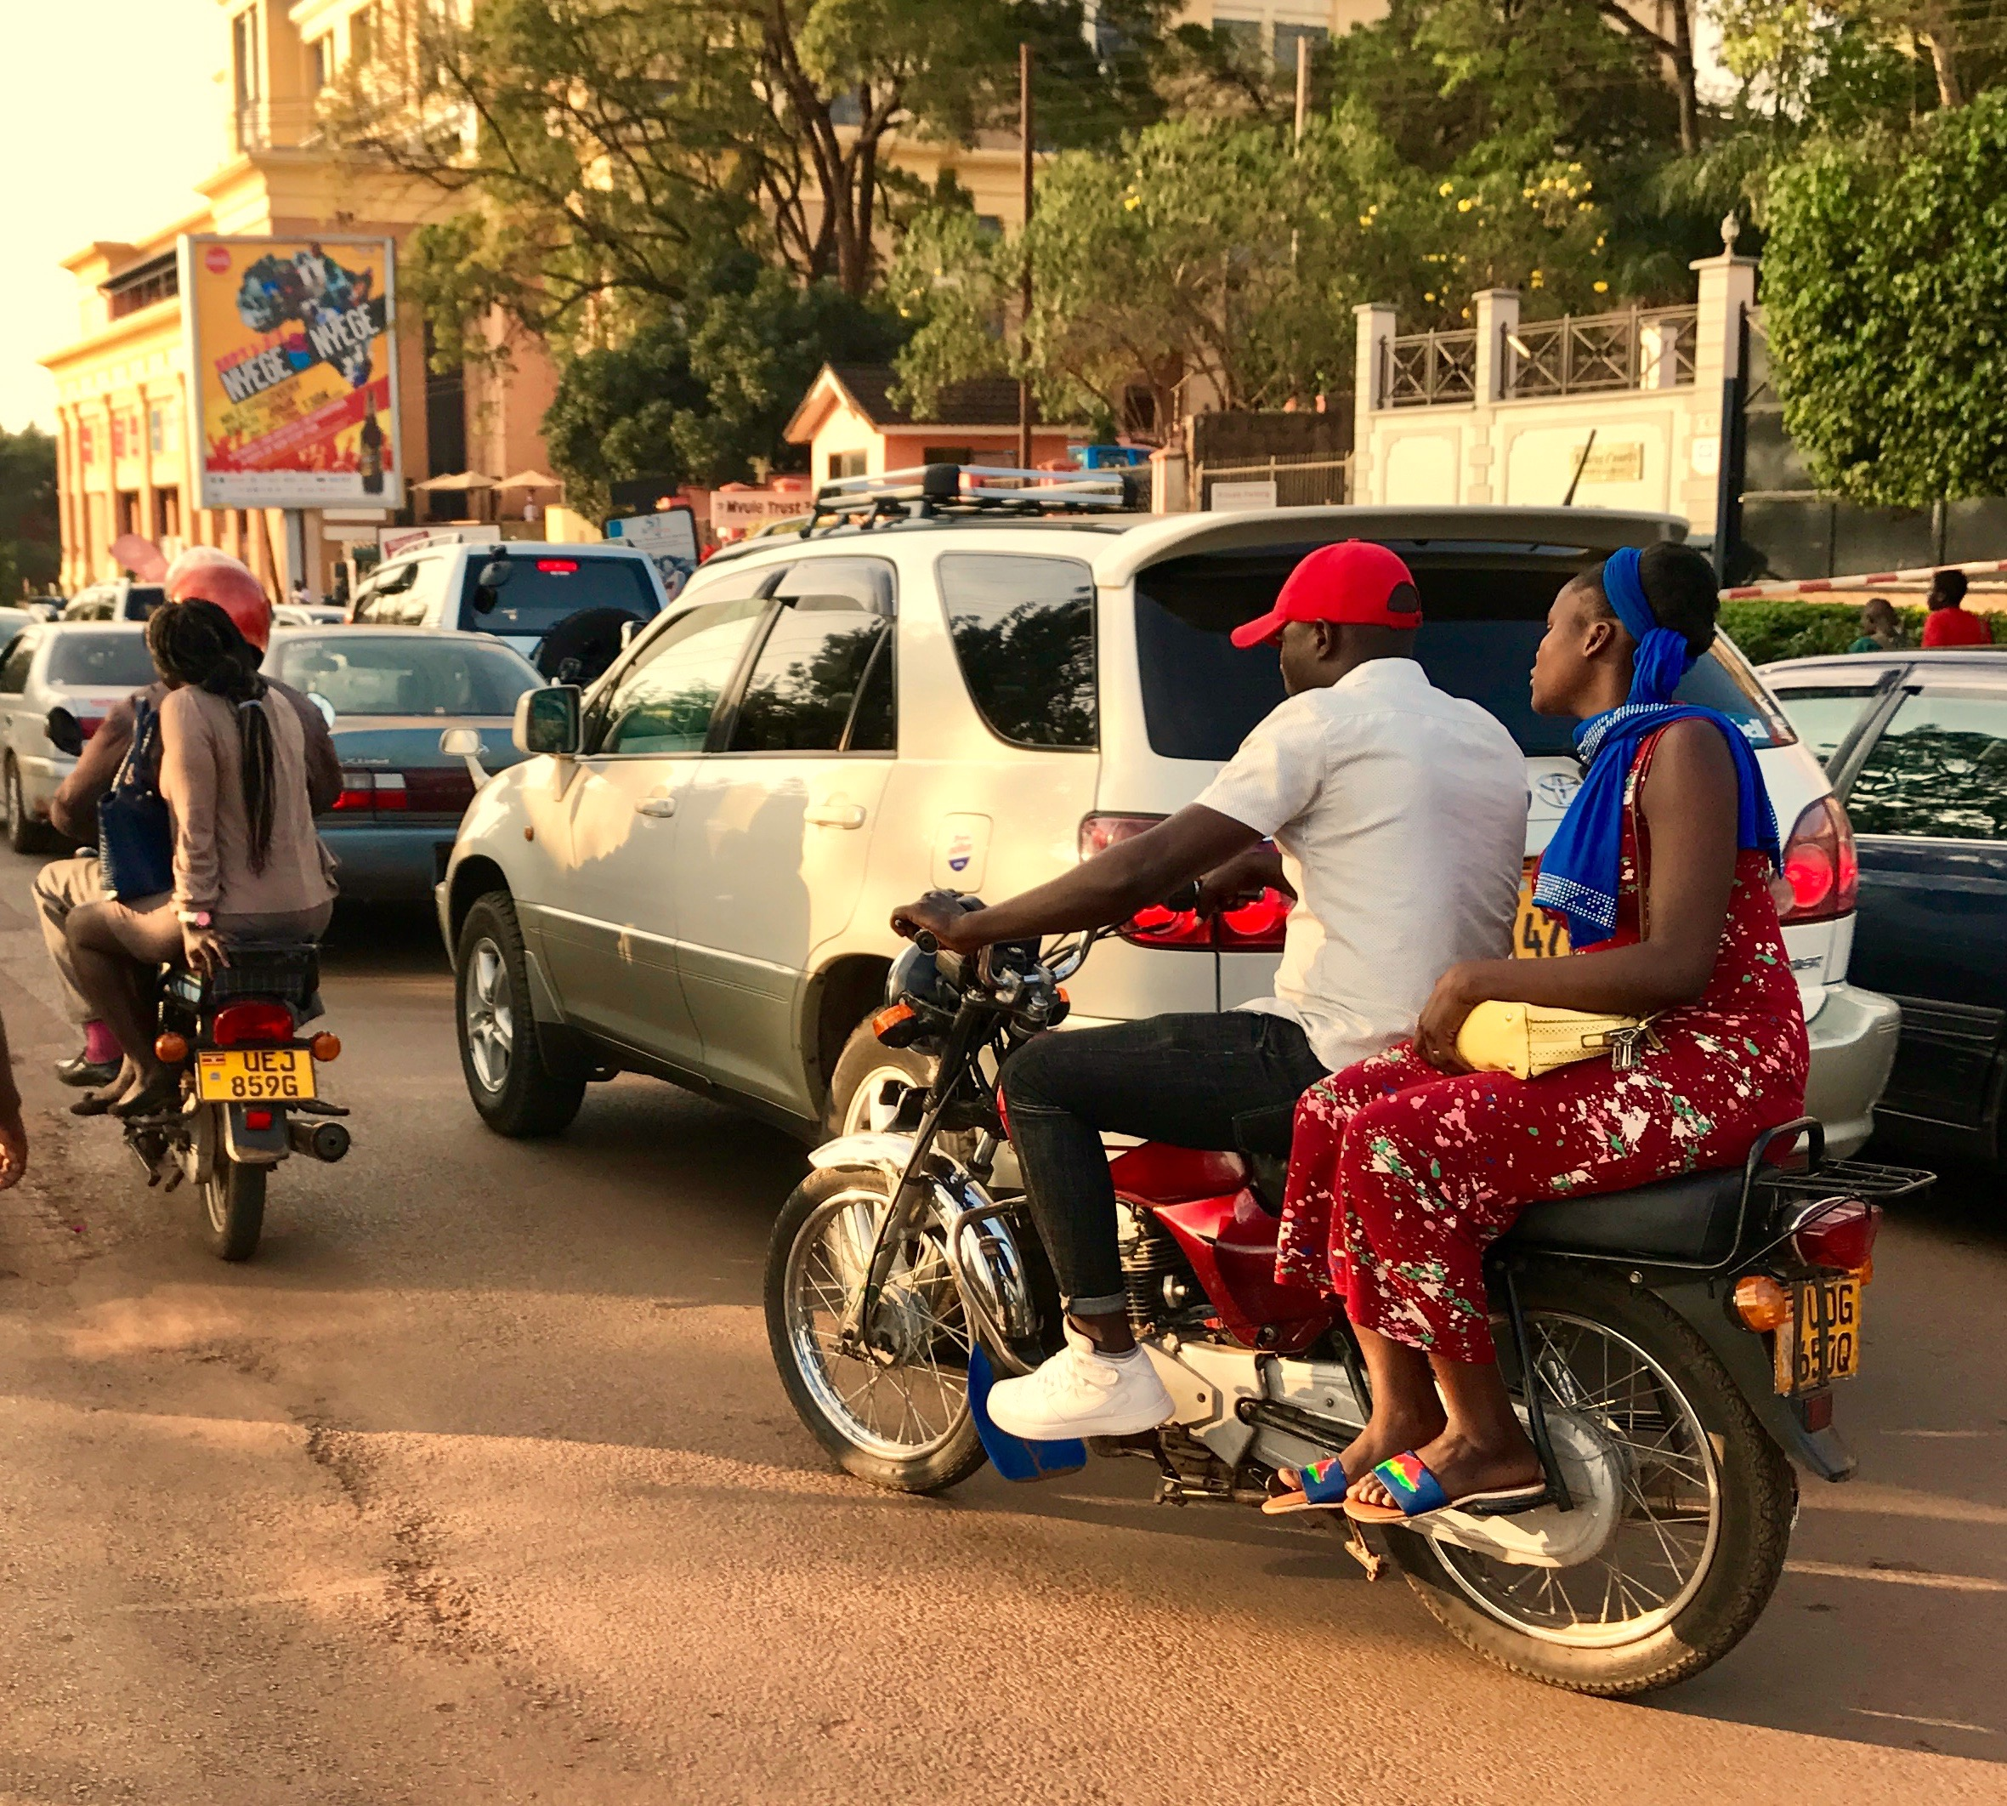
An introduction to contemporary Africa
and to its impressive changes and developments
from the point of view of Social studies

 | Tuesday, 4 June  9.30 – 11  ETHNIC GROUPS AND BORDERS  Eria Olowo Onyango  11.30 – 13  DEMOCRACY IN AFRICA?  George Okiror | Wednesday, 5 June  10 – 13  AFRICA and EUROPE  Giuseppe Mistretta (?) | Thursday, 6 June  10– 13  Round table  PERSPECTIVES ON AFRICAN FUTURE  Jean-Francois Bayart  Irene Bono  Roberto Beneduce  Godfrey Asiimwe Cecilia Pennacini
Monday, 3 June  14.30 – 17.30  AFRICA IN HISTORY  Alice Bellagamba | 14.30 – 16  AFRICAN CHRISTIANITY  Alessandro Gusman  h. 16.30 – 18  ISLAM IN AFRICA  Guido Nicholas Zingari  18.15– 19.45  Film Screening  The gates of Paradise | 14.30 – 17.30 PM  CRISIS, CONFLICTS, TERRORISM  Stefano Dragani | 14.30 –16  THE ENVIRONMENTAL CRISIS  Paola Minoia  16.30 – 18  DEVELOPMENT, AN AMBIGUOUS CONCEPT  Godfrey Asiimwe

The workshop is open to MA students from the University of Turin who can obtain 3CFU for the full attendance. It is also open to external auditors.
A maximum of 30 places in all will be available. To apply is necessary to send an email to alessandro.gusman@unito.it. including a brief motivation letter.
A certificate of attendance will be released on demand.
Attendance is free.

