Torino Digital Education Hackathon
4 Urban Food Circularity

S.A.A. School of Management
Via Ventimiglia, 115
10126 Torino

October 3rd – 4th, 2019

Event Agenda

Torino DigiEduHack 4 Urban Food Circularity – Agenda

03 October 10:00: REGISTRATION

03 October 10:30: WELCOME AND Inspirational session
- Luigi riccardo: Circular Economy in food systems
- daniele consoli, Global Shapers turin hub

- Paola pluchino: La Città vivente - Introduzione al metabolismo urbano CircOlare

03 October 11:00: CHALLENGE INTRODUCTION
- Danny azucar & Paola De Bernardi –
Department of MANAGEMENT, UNITO
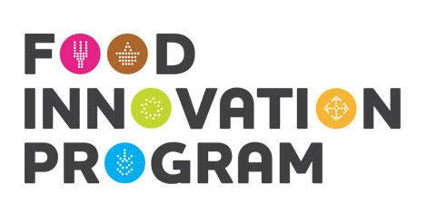
- Simona Grande – Food innovation program
- Iryna Ierokh – Too Good to go
- ivan andreis – caritas diocesana

03 October 12:00: TEAM BUILDING AND PLANNING
- Presentation of individual ideas (optional) – Self Presentation
- team formation

03 October 13:00: LUNCH*

03 October 14:00 HACK BEGINS! TEAM WORK
- Ongoing support from mentors

03 October 16:00: Coffee Break*

03 October 16:30: HACK CONTINUES! TEAM WORK
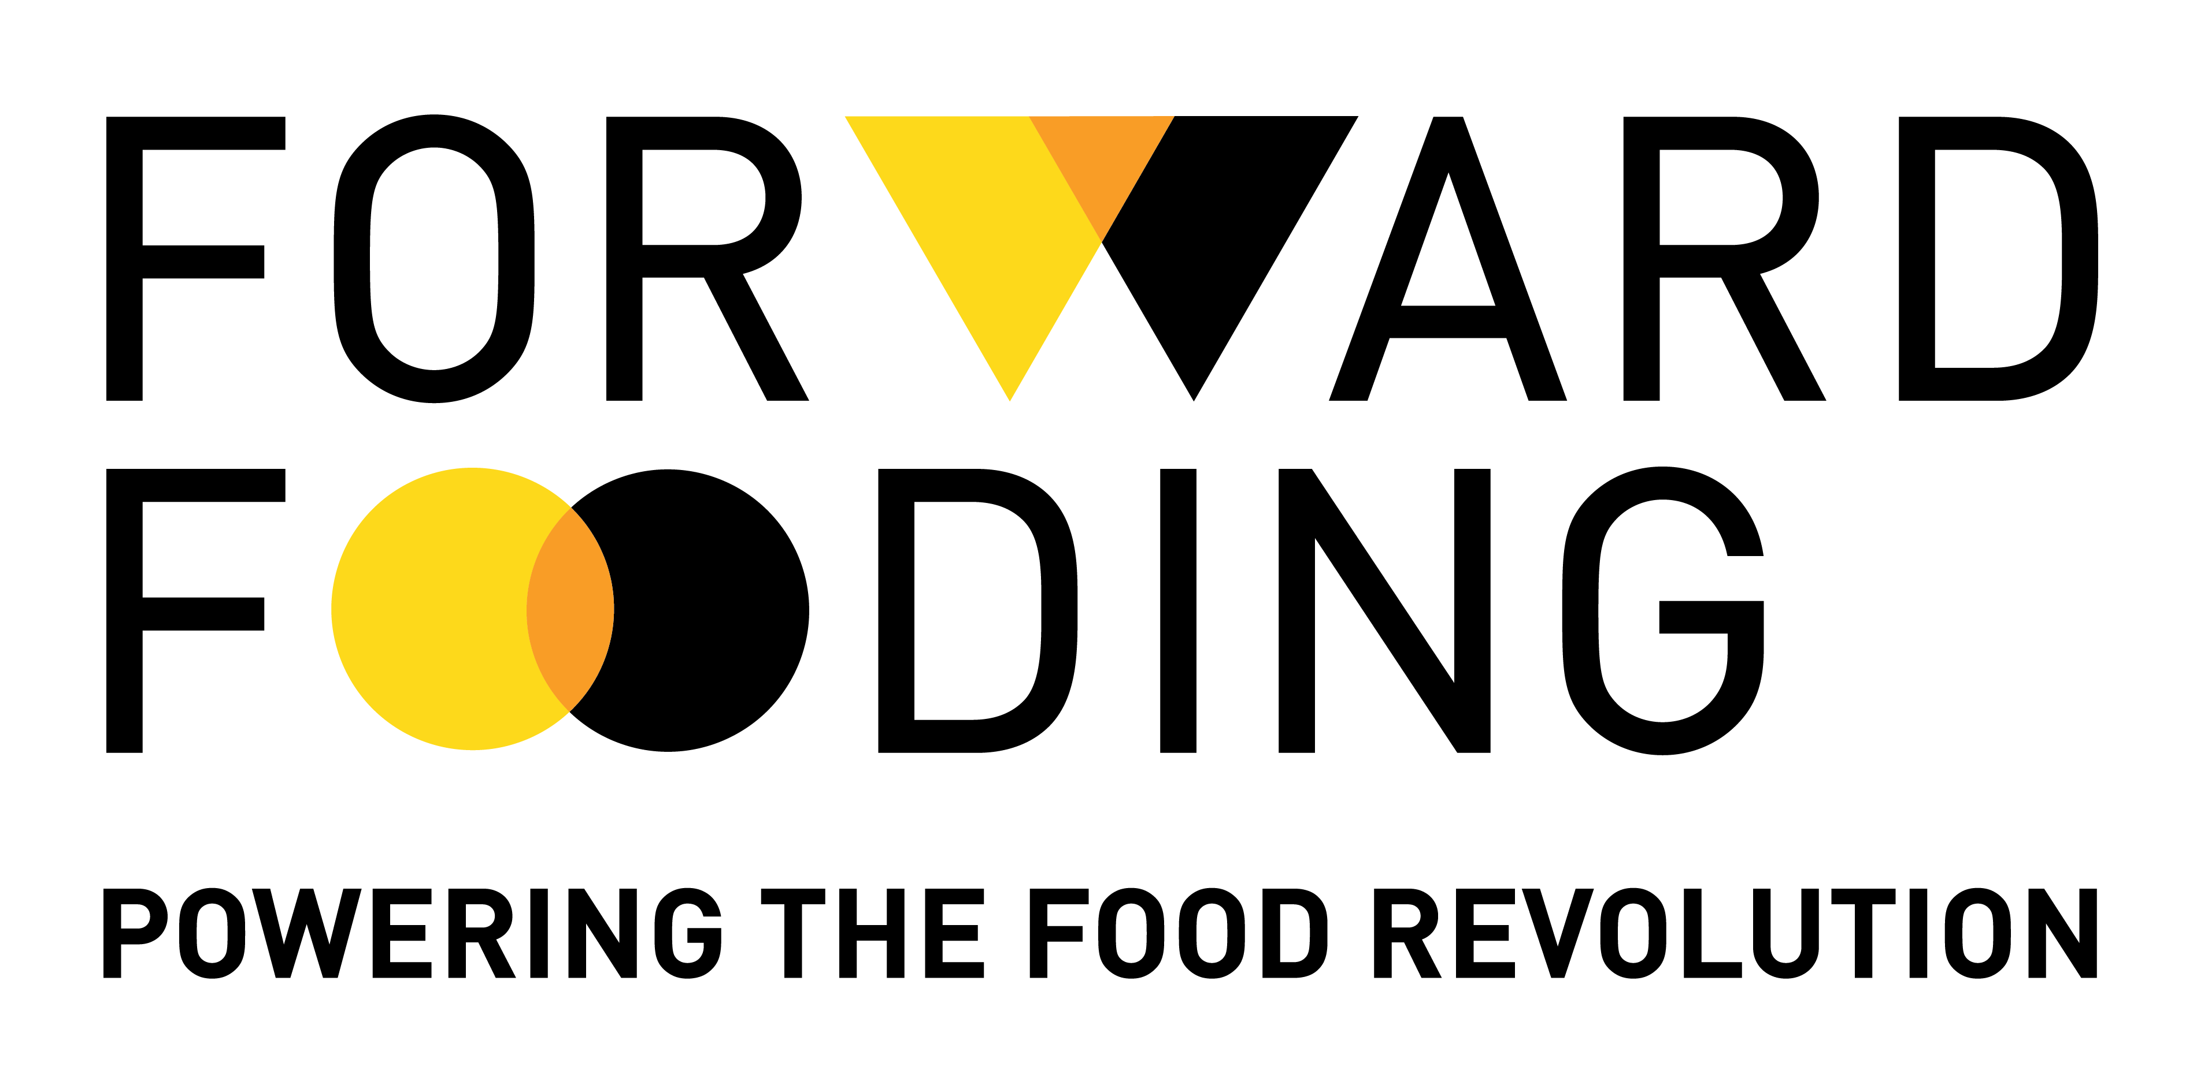
- Alessio D’antino - Business Model
Canvas Introduction

- Ongoing support from mentors

03 October 19:00: Dinner*

03 October 20:00: Pitch training ‘Learn the do's and don’ts of pitching your projects’
- Danny Azucar, University of Turin, Department of management

03 October 20:30: HACK CONTINUES! TEAM WORK

03 October 22:00: Intermission
- Sally Challenge
- Pitch practice (optional)
- Group discussion

03 October 22:30: HACK CONTINUES (off site)- Alternatively, napping time!

04 October 07:30: BREAKFAST*

04 October 08:00: PITCH PRACTICE

04 October 09:00: Participants pitch to judges panel

04 October 10:00 WINNER ANNOUNCEMENT AND CLOSING

Round-the-Clock Activity: Eufemia – escape room!
The city of Turin’s very first Escape Room specific to climate change launches the challenge “Will you be able to Survive Climate Change?” Playing as a group (4-5), you will experience life “at its limits” and will have to find solutions to the challenges encountered. By gaining awareness of how the difficulties experienced in the game are connected to real life, players will be encouraged to make a commitment to act in favor of the planet.
*Note: The caterer “Liberamensa” was born from the challenge of combining food quality with a concrete social commitment.
Since 2008, it has been offering reintegration opportunities through training and employment to people in detention. With this in mind, a bakery (Farina nel sacco), a garden center (Terre e aria) where saffron is produced, and a restaurant were created inside the prison in Turin, as well as catering and gastronomy services.
For further information, see: http://www.liberamensa.org/

