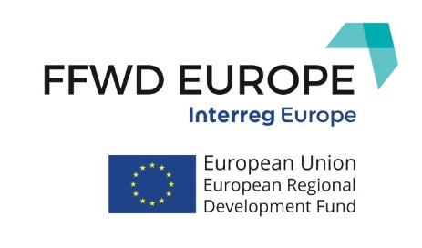
Project No. PGI02042

Steering Committee Meeting

Venue: Kaunas Science and Technology Park
Address: K. Baršausko g. 59 (B corpus – black building), Kaunas / Conference room No.3 (II floor)

AGENDA

4th December, 2019 (Wednesday)

Steering Committee Meeting for FFWD EUROPE partners

14:00 | Welcome coffee
14:00 – 15:00 | Financing  - Overview of partner’s expenditures and budget for PR5 & PR6  - Overview of the budget for phase 1  - Joint Progress Report 6  - Next deadlines and any other business
15:00 – 16:45 | Management  - Overview of the semester  - Stakeholder meetings  - Communication activities  - Management of the project for phase 2  - Action Plans & Feedback from the JS
16:45 – 17:00 | Any other businesses and wrap up
19:00 | Beer degustation and partnership dinner at Volfas Engelman Studio:  Kaunakiemio st. 2 LT-44354 Kaunas  More: https://volfasengelman.lt/en/about-studio/

Project No. PGI02042

Steering Committee Meeting

Venue: Kaunas Science and Technology Park
Address: K. Baršausko g. 59 (B corpus – black building), Kaunas / Conference room No.3 (II floor)

AGENDA

5th December, 2019 (Thursday)

Steering Committee Meeting for FFWD EUROPE Stakeholders and partners

09:45 – 10:00 | Morning coffee
10:00 – 13:00 | AP presentations by all partners (Stakeholders and FFWD EUROPE partners)
13:00 – 14:00 | Lunch
14:00 – 15:00 | Study visit in SANTAKA valley
15:00 – 16:00 | Coffee break  Questions / answers
16:00 – 18:00 | FFWD EUROPE Conference: Global Startup Ecosystem: Collaborate or Compete?  (Stakeholders and FFWD EUROPE partners)

