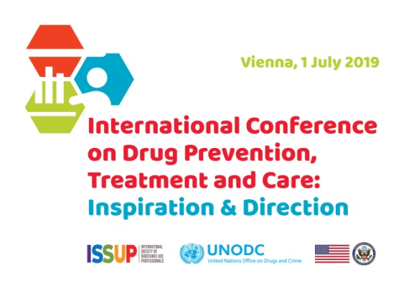
Federica Vigna-Taglianti
Associate Professor of Public Health
Department of Clinical and Biological Sciences
University of Torino

10 February 2019

Dear Dr. Vigna-Taglianti,

It would be my great pleasure to formally invite you to speak at ISSUP’s 5th annual event, the International Conference on Drug Prevention, Treatment and Care – Inspiration and Direction, which will be convened in Vienna, Austria, from July 1-5, 2019 at the Vienna International Centre located at the United Nations Headquarters. ISSUP is an international association of professionals involved with drug prevention, treatment, and recovery, and we are excited to partner not only with the United Nations Office on Drugs and Crime, but also with the Organization of American States, Colombo Plan, World Health Organization, EMCDDA, ICUDDR, CADCA, DFAF and the Global Centre for Credentialing and Certification.

The 5th ISSUP Conference will include training workshops focusing on prevention, treatment, policy-making, community anti-drug coalitions, drug-free workplace programs and other topics, as well as an informative plenary program developed by UNODC. In this context, I would like to invite you to speak in plenary with a particular focus on school based prevention programs, in particular, the Nigerian experience implementing UNPLUGGED within the theme Prevention Innovations. We believe that your expertise in this area would be of particular interest to the audience, and instrumental to the overall success of the event.

Kindly confirm your attendance to Mr. Jan Christopher Gumm (jan-christopher.gumm@un.org) with a copy to Ms. Sanita Suhartono (sanita.suhartono@un.org), no later than 31 March 2019. For any further queries, do not hesitate to contact Mr. Jan Christopher Gumm.

We are pleased to inform you that UNODC will provide you with financial support for your flight ticket and terminal expenses according to the UN rules and regulations.

Please also feel free to contact me with any questions at events@issup.net.

Warm regards,
Joanna Travis-Roberts
ISSUP Executive Director
International Society of Substance Use Professionals (ISSUP)

