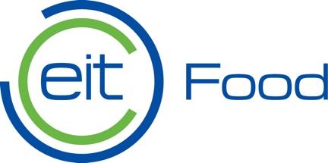
INNOVATOR FELLOWSHIP – “Inno-F”
FOODATHON
Irish College – Leuven

22- 24th March 2019

Participant Guide

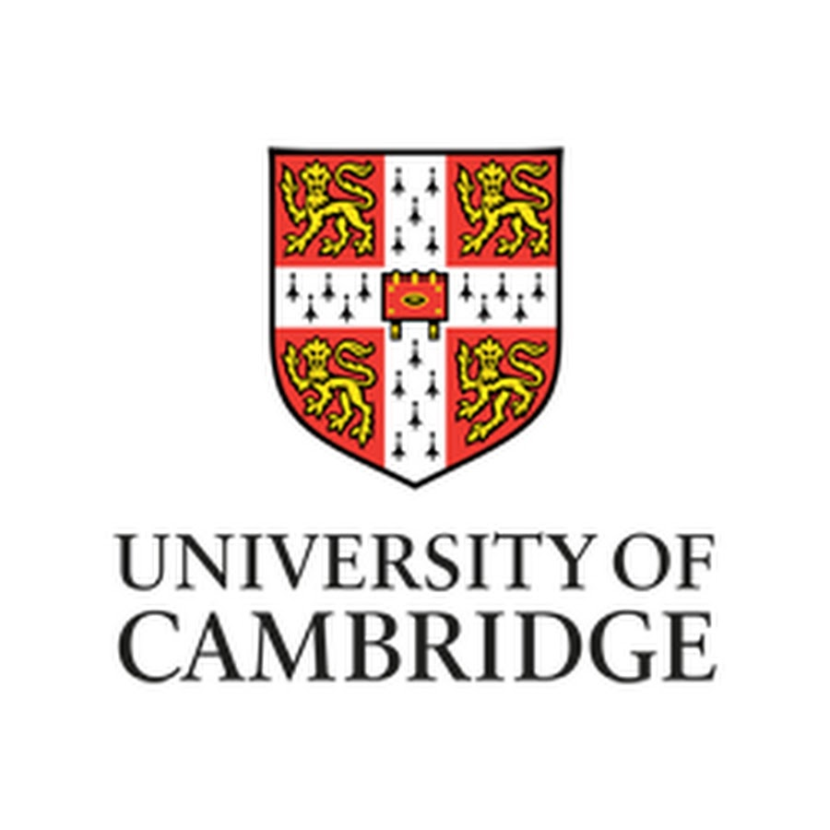
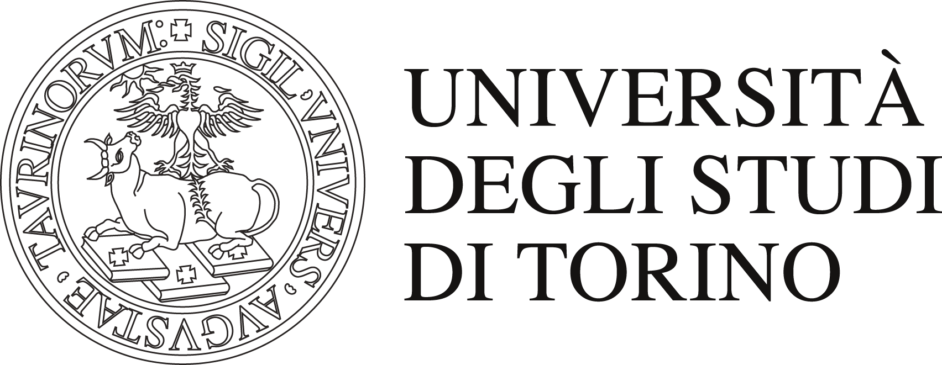
Table of Contents
Agenda Day 1-2 x
Agenda Day 3 x
EIT Food Innovator Fellowship – Foodathon 2019 3
Inno-F 2019 3
Group Training – An Intense Foodathon 4
Mentors and Experts 4
Taylor-made Training – Make a Difference 4
Business Model Canvas 5
Nighttime Activities 5
Yoga 5
Creation of Teams 5
Preparation of Presentations 5
Award 6
Practical Information 6
Food and Beverage 6
Housing 6
How to reach the locations 7
Reduction of use of Paper 7
Catering Service 7
Code of Ethics for Participating in Inno-F 7
Foodathon Product Evaluation Criteria 8
Organizations, Partners, and Sponsors 9

EIT Food Innovator Fellowship - FOODATHON 2019
The EIT Food Innovator Fellowship (Inno-F) is a one-year program designed for postdoctoral researchers. Talented postdocs will be placed in a challenging environment and will be divided into newly created teams to participate in a 48-hour “Foodathon” in order to shape and develop innovative ideas into a fully working business/startup proposal ready to pitch in front of an expert panel.
The expert panel will then select the 5 top innovative ideas, and the winning teams will then have the opportunity to attend a high-level, specifically designed training from June – December 2019 to help participants finalize their project proposal.
The EIT Food Inno-F Fellowship aims at identifying postdoctoral talents worldwide with creative and innovative potential, wishing to expand their skill repertoire through advanced training for the development of an innovative idea with significant impact in the food sector.

For more information please visit: https://www.eitfoodacademy.eu/professionals/innovator-fellowship/

INNO-F 2019
The objective of Inno-F is to empower talents to co-create, address challenges in food sustainability, gain interdisciplinary experiences on innovative ideas capable of further advancing their careers, and foster entrepreneurs ready to respond to global food challenges.

INNO-F 2019 will be a one-year challenge, beginning from the selection of the participants to the realization of the winning project-idea through eye-opening and skill development training. After an initial evaluation of individual ideas, applicants will be selected and invited to participate in the intensive 48-hour Foodathon environment.
The Foodathon will serve to consolidate teams, and assist teams to co-create and further develop their proposed ideas in a multi/interdisciplinary setting.

The teams evaluated as having the most impactful and innovative product at the conclusion of the Foodathon will participate in a high-level complementary skills training and an opportunity to turn their ideas into viable products and achieve a real impact in society.

Group training – An Intense Foodathon

The formation of the Innovator Fellowship teams will be performed by gathering individual talents in a “Hackathon” context.

- The groups, which may consist of 3 individuals, will be constructed based on similarities of individual ideas and complementarities between individual disciplines. At the conclusion of introductions, presentations to the Foodathon, and final selection of team members, teams are highly encouraged to begin the brainstorming process and take full advantage of this limited 48-hour supported innovation ecosystem!

- Explain the use of the member area…...

Mentors and experts of the challenge

- Throughout the entire Foodathon, mentors will closely accompany the teams via a structured mentoring program aimed to assist in the acquisition of the transversal skills necessary to advance the team's original project, via a real working viability frame.
- The mentors (i.e., business experts) are to serve as key figures in the organization development of the teams, and the evolution of the teams initial idea to its final form of a business idea ready to be pitched to a panel of expert judges.

- The team evaluated as having the most breakthrough and innovative business idea at the conclusion of the pitches, will have the chance to participate in a high-level training conducted by the three project's partner organizations – University of Cambridge, University of Turin, and AZTI Tecnalia.

- Participants and mentors will work hand-in-hand to have the project proposal finalized.

Taylor-Made Training – Make a Difference

- The three project's partner organizations will be conducting a tailor-made training for the Foodathon winning teams
- The training will cover areas designed to enable the selected teams to acquire specific transversal skills to further develop and implement their idea: postdoctoral talents will have the opportunity to broaden their horizons and deepen their competencies, learning how to analyze their idea from different angles in order to have a viable, sustainable and impactful project/product or service with an impact in the Food system.

- The training will take place from June – December of 2019. The objective of this training is to stimulate creative thinking regarding ways to solve the main challenges regarding the food sector worldwide (e.g., food shortage, demography, climate change, etc.)

Business Model Canvas

During the Foodathon, participants will be introduced to the essential elements of the Business Model Canvas (BMC) and its applications in order to support participants and groups formulate and compartmentalize their products and solutions.

Participants will be introduced to an expert who will introduce the different parts of the BMC, assisting in applying its methods to the group idea, and assist the groups to formulate solutions regarding their idea/projects such as creation value proposition, researching market opportunities, identifying best accesses to markets, and financial planning for your continued product development.

The BMC methodology helps to develop new business models and its graphic connotation allows for the visual construction of a clear and schematic project. The mentor will remain available to the groups to provide further support and help.

Nighttime activities
TBD
Yoga
TBD

CREATION OF TEAMS

Many of you may have arrived to Inno-F without a (complete) team, if so you have found yourself in the right place!

The creation of interdisciplinary teams is the core of innovation within the program! We will seek to match postdocs based on skills and competencies so as to optimize the multidisciplinary points of view of each team and create an environment for innovation.

Preparation of Presentations

Throughout the Foodathon, teams will work toward the development of a final pitch to be delivered in front of an expert panel comprised of venture capitalists, food scientists, business professors, and entrepreneurs. The teams are highly encouraged to refer to their mentors for the preparation and rehearsal of pitches. Groups will be presented with a final evaluation guide and pitch template.

Pitches will take place on March 24th, at the conclusion of the Foodathon. We will begin with the first round of pitches from 8:30 – 10:00 followed by a 30-minute recess, and conclude the second round of pitches from 10:30 – 12:00.

Following the pitches, participants will be invited for a 1-hour lunch, giving the judges the necessary time to judge the pitches, and the winning team(s) will be announced from 1:45 – 2:00.

NOTE IMPORTANT: PRESENTATIONS AND PITCHES MUST BE IN ENGLISH LANGUAGE.

Award
The winning teams will then be granted a high-level training conducted by the three project’s partner organizations (i.e., University of Cambridge, University of Turin, and AZTI Tecnalia). Participants and mentors will work hand-in-hand to have the project proposal finalized by the conclusion of the 48-hour Inno-F.

Practical Information
- The works of the INNO-F held in Brussels, Belgium will begin at 12 on March 22nd, and conclude at 2 pm on March 24th.
- The organization will provide stationery materials and guarantee Wi-Fi connection for the duration of the event.
- Each participant must provide their personal work devices (i.e., pc, tablet, etc.).
Food and Beverage
- At the INNO-F, a coffee station with drinks and snacks will be available to participants for the entire duration of the event;
- Participants are invited to bring a reusable cup for water / coffee / tea
- Special meals based on dietary needs (e.g., vegetarian, gluten free, vegan, etc.) will be made available during meal times by the Inno-F organizers.
Housing:
- Postdocs will be housed at the historic Irish College in Leuven, Belgium.
- Applicants may share sleeping quarters with team members if they desire
- Individuals may declare to have arrangements made for single sleeping quarters
How to reach the locations
- Irish College Brussels Janseniusstraat 1, 3000 Leuven, Belgium
- Add directions from Airport
- Add directions from train station
- Add list of nearby bus/metro stations and lines

Reduction of use of paper
- All the working materials of Inno-F will be made available in electronic format, with the exception of the basic material that will be provided in consultation in paper format (limited number of copies) during the Foodathon.
Catering service
- The catering service was chosen on the basis of criteria of environmental sustainability of the ingredients, of the materials used and of the possibility to dispose of the packaging and dishes in the best possible way. Food for vegans, vegetarians and people with celiac disease has been made available.
Code of Ethics for participation in Inno-F
Before kicking off the Foodathon, all participants must sign and agree to our guidelines regarding intellectual property of developed idea, and code of conduct and research integrity.

Foodathon Product Evaluation Criteria
In line with the evaluation criteria established by the EIT Food consortium, the general criteria are highlighted, through which the solutions will be evaluated:
1. Consistency
The proposal clearly addresses the defined challenge, in particular:
- responding to the objectives of sustainability on a local scale or national scale
- clearly indicating the target of the solution and the needs to which it responds, with particular reference to solutions for the food sector (e.g., sustainability, food waste, nutrition, etc.)
2. Feasibility
The proposal has a solid foundation to be implemented from the technical, legal-administrative, economic-financial, management / organizational point of view, etc. which make implementation possible. Evaluation elements:
- presence of technical and / or procedural details related to all the phases of implementation of the solution;
- elaboration of a project that highlights the practical use of the solution by the target user.
3. Adherence to the Food Challenges: the proposal is focused on worldwide food challenges with an innovative product that helps address at least one of the 6 EIT Food’s Strategic Objectives.
- Overcome low consumer trust: support Europeans in the transition towards a smart food system that is inclusive and trusted;
- Create consumer valued food for healthier nutrition: enable individuals to make informed and affordable personal nutrition choices;
- Build a consumer-centric connected food system: develop a digital food supply network with consumers and industry as equal partners;
- Enhance sustainability: develop solutions to transform the traditional ‘produce-use-dispose’ model into a circular bio-economy;
- Educate to engage, innovate and advance: provide ‘food system’ skills for students, entrepreneurs and professionals through advanced training programmes and open online courses, and
- Catalyse food entrepreneurship and innovation: foster innovation at all stages of business creation.

Organizations, Partners and Sponsors
- University of Cambridge
- University of Turin – Department of Management
- AZTI Tecnalia

