http://www.univ-unita.eu/

condivisione Digieduhack 2021 con Unita
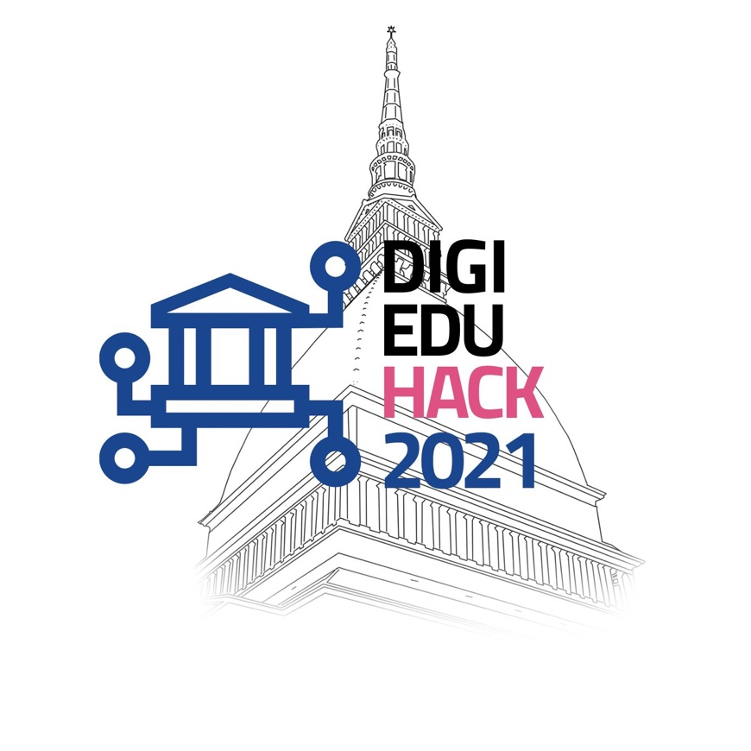
The Department of Management of the University of Turin is organizing the third online edition of the Turin DigiEduHack, titled “DigiEduHack Goes Circular”, that will take place on November 9-10th, 2021 and will be supported by EIT Food.
DigiEduHack is a series of hackathons happening all around the world simultaneously, focusing on co-creating the future of education in the digital age.
Only 8,6% of the world can be currently defined as circular. The time to act is now! Join us to learn more about the topic from international experts and get ready to hack Digital Learning Tools to support a Circular Economy transition and a Food Systems transformation (Challenge #18).
Participation is free of charge, both individuals and teams can apply. All participants will receive a certificate. Solutions will be judged by a jury of experts and the winners will be able to compete in the final global award contest and have the chance to win €5000.
The deadline for applications is November 4th.

Apply here:
https://digieduhack.com/en/turin-digieduhack-goes-circular-2
For more information:
paola.debernardi@unito.it
simona.grande@unito.it

