H2020 MSCA-ITN 2017
iPLACENTA
Innovation in modelling Placenta
for Maternal and Fetal Health

D 5.1 Report on dissemination strategy of project results to scientific community – No. 1
Report
Coordinating institution: University of Dundee (UNIVDUN)
Lead beneficiary, WP 5: Università degli Studi di Torino (UNITO)

Coordinator: Colin Murdoch, UNIVDUN
Author: Benedetta Bussolati, UNITO, Mirren Augustin, UNIVDUN
Reader: Colin Murdoch, UNIVDUN
Project website: www.iplacenta.eu
Grant Agreement No.: 765274

Deliverable identification
Project number | 765274
Project acronym | iPLACENTA
Project title | Innovation in modelling Placenta for Maternal and Fetal Health
Starting date | 01.01.2018
Duration | 48 months
Call (part) identifier | H2020 MSCA-ITN-2017 (ETN)
Project start date | 01.01.2018
Deliverable no. | D5.1
Deliverable Title | Report on dissemination strategy of project results to scientific community – No. 1
Work Package no. | WP5
Work Package Title | Dissemination, exploitation and outreach
Lead Beneficiary | UNITO
Author(s) | Benedetta Bussolati (UNITO), Mirren Augustin (UNIVDUN)
Reader(s) | Colin Murdoch (UNIVDUN)
Delivery date of the deliverable | 31.08.2019 (M20)
Date of Submission
Version | 1.0
Nature | R
Dissemination level | P

Abbreviations
APEC Action on Pre-eclampsia
D Deliverable
DOC Dissemination and Outreach Committee
ESR Early Stage Researcher
ETN European Training Network
IFPA International Federation of Placenta Associations
MS Milestone
UNITO University of Torino
UNIVDUN University of Dundee
WP Work Package

Table of Contents

1. Introduction 3
1.1. Dissemination objectives 3
1.2. Scope of this report 4
2. Dissemination within iPLACENTA 4
3. Conferences 5
4. Publications 6
5. Other 7
5.1. Action on Pre-eclampsia (APEC) 8
5.2. Brochure 8
5.3. Website, social media and other formats (webinar, video) 8
6. Evaluation strategy 9
7. Impact to date 10

Introduction

Dissemination objectives
iPLACENTA as an MSCA European Training Network (ETN) is unique in its focus on Maternal and Fetal Health and its interdisciplinary and intersectoral approach. It provides training towards a highly pertinent skillset by bringing in a set of researchers who have different backgrounds – from clinical research to basic science, mathematics and engineering – and are active in a variety of disciplines in medical research. A strategic aim of the programme is to reciprocally bring fetal medicine to the wider scientific community.
The early-stage researchers (ESRs) are thus expected
- to contribute by their research to our understanding of the placenta and major placenta-related disease including pre-eclampsia and intra-uterine growth restriction (IUGR), but also
- to draw attention to the field of Maternal and Fetal Health by taking the topic out to other medical sciences and different disciplines and sectors.
Besides the objective of producing and publishing or exploiting results for their best use by the wider community, iPLACENTA as an ETN has been conceived to ensure that are well-trained in scientific and lay communication and encourages engagement with the involved communities at a variety of levels.

Scope of this report
This report outlines the strategy for the dissemination of project results of the iPLACENTA project to the scientific community, including academia, industry, medical doctors and midwives. The document will be updated on an annual basis, adding any new opportunities for dissemination as they arise. The impact is reported separately.
The report falls under Work Package 5, which is dedicated to dissemination and outreach activities as a whole. The report is flanked by the annual report on the public engagement strategy (D5.11, status: confidential), and overviews of ESR publications (D5.4, public) and presentations at international conferences (D5.7, public).
An exploitation plan was produced in Month 10 and will be updated in Year 3 (D6.4, confidential). The ESRs’ personal plans are captured in their Career Development Plans (WP4: Training), produced and reviewed annually, and the ESRs report back to the project management team on their achievements.
The Dissemination and Outreach Committee (DOC), led by Prof Benedetta Bussolati of the University of Torino (UNITO) has the task to monitor and evaluate activities against the backdrop of the objectives set out on the grant proposal, and to organise routes of dissemination across the network. The reports are collated by the project manager, Mirren Augustin.

2. Dissemination within iPLACENTA
iPLACENTA involves ten institutes working on three distinct scientific work packages with cross-cutting research interests.
The consortium will hold annual network meetings at which projects’ progress and results will be presented, giving the opportunity to discuss further pathways for dissemination and exploitation with all members of the consortium, including partners and external advisors. The first network meeting was held in Torino in June 2019, coinciding with the project check carried out by the European Commission’s Research Executive Agency (REA). Future network meetings are scheduled to coincide with iPLACENTA-specific training events or symposia, so as to support networking opportunities and focussed dissemination to scientific audiences at a larger scale (see 4. and 5.).
The University of Dundee (UNIVDUN) Management Team shall support the DOC in ensuring that all members of the consortium are made aware of the publication of results.

3. Conferences
Active participation and networking at regional, national and international conferences will provide the opportunity for ESRs and supervisors to showcase individual research activities as well as the iPLACENTA project as a whole. ESRs are expected to present at 2 or more international meetings per year, totalling 6 poster or oral presentations over the course of the project.
Some preliminary results are already being shown in this first phase of the project, whereas other ESRs are concentrating on presenting project goals and methods and exchanging ideas. Activity is expected to increase in 2020 and 2021. Presentations at international conferences are listed in D5.7.
Selection of national and international conferences in 2019:
iPLACENTA
- First Network Meeting (8 oral presentations by ESRs, 14 posters)
Fetal medicine and reproductive sciences
- Society of Reproductive Investigation Annual Meeting (SRI) (6 participants)
- Fetal Medicine Foundation Annual Conference (3 participants)
- Fetal Growth Congress / World Congress on Ultrasound in Obstetrics and Gynecology (ISUOG)
- British Maternal and Fetal Medicine Society (BMFMS)
- Reprosciences
Wider scientific community
- European Mathematical Genetic Meeting (EMGM)
- European Society for Microcirculation/European Vascular Biology Organisation: Joint ESM-EVBO Meeting
- International Conference of Biophotonics (ICOB)
- International Society of Extracellular Vesicles (ISEV)
- Photonex Exhibition and Conference
- SINAPSE Annual Scientific Meeting
- Society for Laboratory Automation and Screening (SLAS)
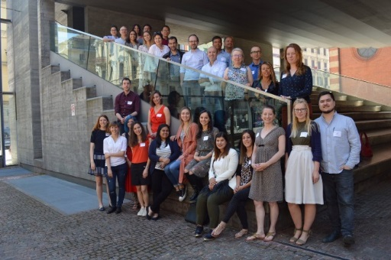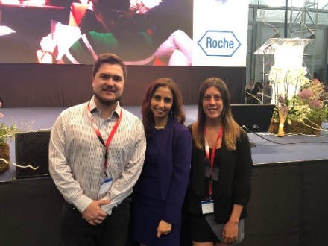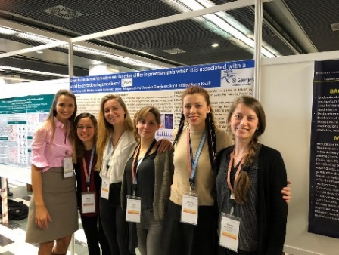
iPLACENTA 1st Network Meeting Fetal Medicine Foundation Annual Society of Reproductive Investigation
Torino (June 2019) Congress, Alicante (June 2019) Annual Meeting, Paris (March 2019)

Conferences organised through iPLACENTA members
The following symposia will provide a comprehensive showcase of the iPLACENTA project with participation from all ESRs:
- iPLACENTA Network Meetings (2019, 2020, 2021)
- International Federation of Placenta Associations (IFPA) Meeting, 2020:
There will be a dedicated iPLACENTA session with keynote speech, 4 presentation slots and posters.
- iPLACENTA conference, 2021(being developed)
The iPLACENTA conference will form the final official dissemination event before project end. The conference programme and abstracts will be published and held on the iPLACENTA website www.iplacenta.eu.

4. Publications
ESRs are expected to publish in high-impact peer-reviewed journals following the track record of their primary supervisors, and with members of the consortium providing added avenues for publication. The aim is for each ESR to publish three high-impact scientific publications and three collaborative review articles during the course of the iPLACENTA project.
iPLACENTA will target journals which are fetal medicine or placenta-based, then leverage its connections with wider scientific parties to promote fetal medicine in different scientific arenas.

Future opportunities through iPLACENTA principal investigators:
- iPLACENTA-themed edition in a specialized international journal
- IFPA conference proceedings published in a specialized international journal
- Special edition in an non-specialized international journal (editor: Colin Murdoch)

Publications to date:
- 2 reviews published in International Journal of Molecular Sciences, Special Issue “Molecular and Cellular Mechanisms of Preeclampsia”, Volume 20 Issue 13 (2019) – impact factor 4.183
- 1 review published in Oxidative Medicine and Cellular Longevity, Hindawi, Volume 2019 – impact factor 4.868
- 1 review publication in review, Antioxidants – impact factor 4.520
Full details are provided in D5.4.
All publications, including posters and other products, duly acknowledge EU funding according to the European Commssion guidance provided.

Open Access
iPLACENTA is signed up to the European Commission’s Open Access agenda. It will ensure that where possible, publications will be open-access, and it will endeavour to make the research data underpinning publications openly accessible as well. ESRs have received training from our partner FOSTER to better understand the policy and follow Open Science guidelines (EU-funded project “Fostering the practical implementation of Open Science in Horizon 2020 and beyond”, 2017-19).

5. Other
News of the European funding awarded to the iPLACENTA project has been disseminated by our partners capable of reaching a wider audience to include industry, policy makers, media and civil society:
- UK-based patient group Action on Pre-eclampsia (APEC): newsletter, 8000 subscribers
- Industry partner FujiFilm VisualSonics: newsletter, 2000 subscribers
- Organ-on-chip company Mimetas: website, 260 views
- Open Science partner FOSTER: webinar with project coordinator Dr Colin Murdoch, 20 participants
We will be able to return to these resources where suitable to disseminate research results involving the partners. Particular support in targeting maternal and fetal health professionals will be provided by APEC. A comprehensive brochure that gives an overview of the research results shall be produced towards the project end. Meanwhile, ongoing project updates will be delivered primarily via the iPLACENTA website and social media platforms.

5.1. Action on Pre-eclampsia (APEC)
iPLACENTA will work with partnering patient group APEC for an effective approach to healthcare professionals in the UK. In particular, two events are currently being planned with iPLACENTA participation:
- APEC Experts Day 2020 with 2-3 ESR presentations
- APEC Study Day (midwife training event) to be organised in 2020 with a talk from selected ESRs about the iPLACENTA project. This will be first APEC-organised event to take place in Scotland.

5.2. Brochure
There are plans to produce a brochure aimed at maternal and fetal healthcare professionals for the APEC Study Day in 2020. The brochure will be updated and revised, and translated into participating countries’ languages if requested, to be ready for the iPLACENTA final conference in 2021. The brochure will be disseminated as appropriate via available APEC, iPLACENTA and consortium members’ channels.

5.3. Website, social media and other formats (webinar, video)
Website
The dedicated project website www.iplacenta.eu contains the following sections which will be continuously updated:
- Description of the project aims and achievements
- News related to the project
- Project publications (articles, posters, any other)
- ESR and supervisor biographies
- Project blog with ESR contributions on various PhD-related topics
The project description on www.cordis.europa.eu contains a summary of project objectives and links to project results in the form of deliverables and peer-reviewed articles.

Social media
iPLACENTA is present on these social media platforms and aims to increase its number of followers throughout the project:
- Twitter (@iplacenta, #iplacenta)
- ResearchGate (Horizon 2020 MSCA-ITN – iPLACENTA)
- LinkedIn (iPLACENTA)
- Facebook (iPlacenta page)
- Instagram (iplacenta_itn)
Twitter, ResearchGate and LinkedIn are being used specifically to disseminate research results to the scientific community, while Facebook and Instagram are used to also communicate the ESRs’ experiences and gather broader interest.

Other formats (webinar, video)
ESRs are encouraged to explore new technological opportunities for dissemination to a wider scientific community, and to share their experiences with each other. For example, Gwenaëlle Rabussier (ESR01) has held an “Ask the expert” webinar about 3D cell culture for Mimetas in April 2019, available on the Mimetas website.
ESRs have also worked together to produce a video which was published on the occasion of World Preeclampsia Day on 22 May 2019:
“iPLACENTA Early-Stage Researchers: Introducing ourselves (H2020 Marie Skłodowska-Curie Actions)” (YouTube)
They plan to make further short films about their research topics.

6. Evaluation strategy
The project’s impact in terms of the dissemination of scientific results will be evaluated quantitatively on the numbers of:
- conferences and workshops with presentations (oral/poster) from ESRs, or supervisors in the context of iPLACENTA
- publications by the consortium
- citations; access statistics
- press releases relating to project results
- participants at the iPLACENTA dedicated meetings (IFPA session, Satellite symposium)
- participants at the midwife training event and study day
- visitors to the iPLACENTA website and blog (Google Analytics: website sessions), viewers of the video
- social media followers
Qualitatively, we will consider feedback from iPLACENTA-dedicated events and the emergence of new or enhanced collaborations as important indicators of project impact.
This information will be collected on an ongoing basis and feed into the Dissemination and Outreach Committee’s annual strategy recommendations.

7. Impact to date
In their first year on the project, the ESRs have presented their projects at a number of international, national and regional conferences on Maternal and Fetal Health, but also in other disciplines (e.g. extracellular vesicles) and sectors (e.g. mathematical genetics, biophotonics), with 10 separate poster presentations.
Three reviews have been published and one is under review, in journals with an impact factor >4 (989 views on 23/07/2019). Overall, the ESRs are in an excellent position to disseminate their project results, with the encouragement of world-leading scientists collaborating in iPLACENTA.
In 2020 there will be time specifically dedicated to iPLACENTA research at important dissemination events. iPLACENTA principal investigator Fergus McCarthy (University College Cork) has arranged for a specific session at IFPA international conference in Amsterdam to showcase iPLACENTA research alongside other research. Through our partner organisation Action on Pre-eclampsia (APEC) there will be two events focusing on Maternal and Fetal Health professionals (APEC Experts Day and Study Day) with time specifically dedicated to iPLACENTA research.
The ESRs have been actively contributing material shared on the website (access statistics: 1230 sessions, 10/01-23/07/2019) and on social media platforms linked to iPLACENTA (e.g. introductory video, blog posts). This helps to raise awareness, and to increase the number of followers who can benefit from future publication of research results across these channels. Most activity has so far been registered on Twitter (117 followers on 23/07/2019, 59 tweets).
The project has attracted interest from the Placental Atlas Tool (https://pat.nichd.nih.gov/), a resource developed by Human Placenta Project, the largest US-funded project on placenta research, and talks are currently being held how iPLACENTA might engage with this.

